Grade 1 & 2 Choice Board- Week of May 18th-22nd
Physical Movement with Patterns  Make up a movement (or sound) pattern with at least 3 different actions.  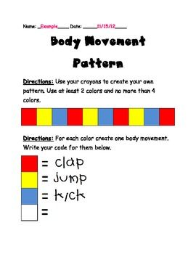 |  | Find 8 things in your house to measure. Find something to measure with. Estimate first and then measure. Find the differences between your estimates and the actual measurements.  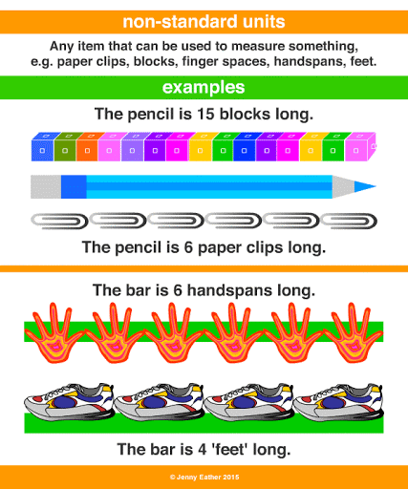 | Ice-Cream Scream  Materials  -2 cups ice, 1 cup of half and half, ½ cup salt, (coarse salt works best) ½ cup of sugar, ½ tsp. vanilla, 1 gallon-size and 1 quart-size zip lock bag.  -Place ice and salt in the large bag. In the small bag, mix the other ingredients. Squeeze out air; seal. Place the small bag inside the big bag. Seal; shake and knead the bag for ten minutes, until the cream thickens. Remove the small bag, rinse, open and eat the results.
Letters of the alphabet  Choose a letter of the alphabet. Find 3 things that begin with that letter. How many letters can you do?  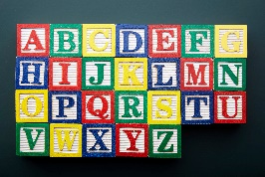  - Airplane, apple, alligator  - Ball, block, balloon  - Car, cat, castle |  | I Spy Sums  Materials: Deck of cards (face cards removed) numbers 5-10 but choose numbers your child should practice. Create 2 rows of 6 cards (12 cards) face up. A player chooses two cards in secret and states the sum. The other player must guess what two cards made the sum. “I spy with my little eye two cards with a sum of ___.” Is there more than one possibility for the sum? | Read or listen to a story. Create a different ending to the story and either tell it to someone or write it.
Make a number book. Each page can feature a different number. Draw pictures or show different math expressions to represent the number.  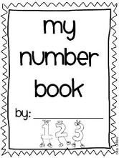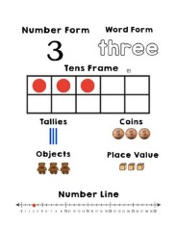 |  | Create a 4 to 6-frame comic strip based on a topic of choice. Draw pictures and use speech and thought bubbles to show what the characters are saying and thinking. | Choose an object in your home. Write down 3 clues that describe that object. Hide the object and read your clues one at a time to someone else. See if they can guess your object by using the clues that you give them.
Remember to visit at least once a week. www.sumdog.com (Mrs. Higgins sets a new challenge each week and can track your progress and time spent on it.)
If you have lost your child’s username and password, please contact me.

 | Remember to read each day and visit to read the story Mrs. Fitzpatrick assigned to you. www.getepic.com (Mrs. Fitzpatrick sends a book for you to read in your mailbox daily and can track your progress and time spent on it.)

